 | Assignment No. 2  Semester: Spring 2019  CS201 – Introduction to Programming |  | Total Marks: 20  Due Date:  May 29, 2019
Instructions
Please read the following instructions carefully before submitting assignment:
It should be clear that your assignment will not get any credit if:

- Assignment is submitted after due date.
- Submitted assignment does not open or file is corrupt.
- Assignment is copied (From internet/students).

Software allowed to develop Assignment
- Dev C++

Objectives:
To enable students to understand and practice the concepts of:
- Variables and operators
- Loops / Repetition Structures
- Switch Statement
- Array Implementation with pointers
- Functions

Assignment Submission Instructions
You have to submit only.cpp file on the Assignments interface of CS201 at VULMS. Assignment submitted in any other format will not be accepted and will be graded zero marks.

Assignment

Arrays are used to store same type of data in consecutive memory locations. It stores a fixed amount of data elements in the memory. Array elements are accessed using index. Index starts from 0. Following is an example of array declaration and initialization.
int a[5] = {2, 4, 6, 8, 10};
// index 0 stores the value 2
// index 1 stores the value 4
// index 2 stores the value 6
// index 3 stores the value 8
// index 4 stores the value 10

Assignment Statement:
Write a menu based system in C++ that will take input from user for the following menu. You will create an array. And perform the following operations on the array.
Press 1 To Enter Values In Array.
Press 2 To Read Array Elements.
Press 3 To Show Array Elements In Reverse Order.
Press 4 To Show Array Elements Which Are Multiples Of 3.
Press 5 To Show Sum Of All The Elements.
Press 6 To Exit.

Solution Instructions:
➔ Use switch statement for the menu based system.
➔You have to use pointers for option 2, 3, 4, 5.
➔You can use user defined functions for each of the task mentioned above to manage your code.

To Enter Values In Array | getValues();
To Read Array Elements | displayArray();
To Show Array Elements In Reverse Order | reverseArray();
To Show Array Elements Which Are Multiples Of 3. | multipleOf3();
To Show Sum Of All The Elements | sumOfElements();

If the user chooses any option other than 1, for the first time, when array is empty, so the user will get a message
“Array is empty, first enter data in array" as shown in the sample output.

Sample output:

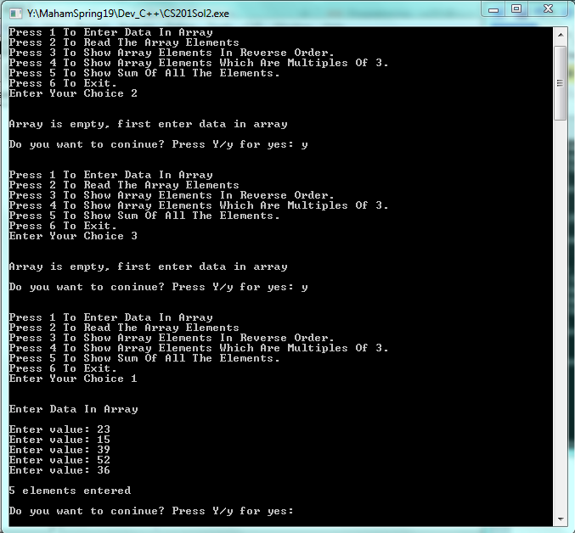

Sample output:

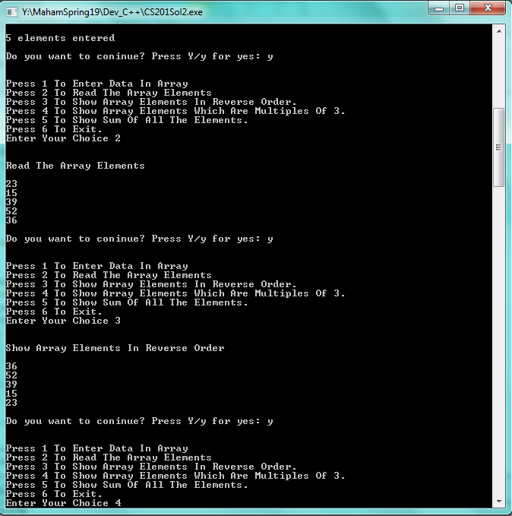

Sample output:

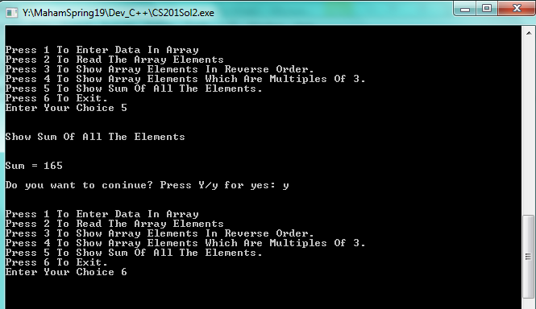

Lectures Covered: This assignment covers Lecture # 11-15.
Deadline: The deadline to submit your assignment solution is May 29, 2019. Your assignment must be submitted within the due date through VULMS. No assignment will be accepted through email after the due date.

